January, 2018
Volunteer Guide: Greenway Care – North Eaton Trail

What:
Greenway Care along the Eaton Trail North of Copper Avenue
Where:
Volunteers will meet at the trail head on Copper & Friant Avenue in Fresno, CA at 8am.
When:
Saturday, January 13th 8:00am – 11:00am
What to Expect:
Thank you for coming on out to the Eaton Trail with Tree Fresno. It is a great opportunity to enjoy nature, get a little exercise, and give back to your community. Volunteer duties include pruning trees, picking up debris and clearing underbrush. The activity level is moderate.
What to Wear:
Please wear durable clothing, long sleeves, boots, and long pants are best when working around the branches and tall grass. Please wear work gloves, red ants bite, and nettle stings!
What to Bring:
Bring along a bottle of water or two.
Registration Form:
Please bring your Volunteer Registration Form if you have not previously turned one in.
Safety First:
Watch for tripping hazards- Such as fallen branches, holes and rocks. Step carefully- when working in tall grass and piles of debris. Be mindful of snakes and other wildlife that use these types of habitats.
Be mindful - When working in a group please be mindful of others when using tools. Group members will be sawing and pruning branches so be aware of who might be under you, or sawing above you.
Stay hydrated - Drink plenty of water especially on hot days or when physically exerting oneself. We will take rest breaks, but feel free to rest when needed.
Be Respectful- This is just a reminder to be respectful of others in the group and those passing by on the greenway. When working on projects with Tree Fresno, you are representing the organization and the community.
Contact:
Please contact Brianna Woodsford for more information
(O) 559.221.5556
(M) 559.473.7682
(E) brianna@treefresno.org
Maps:
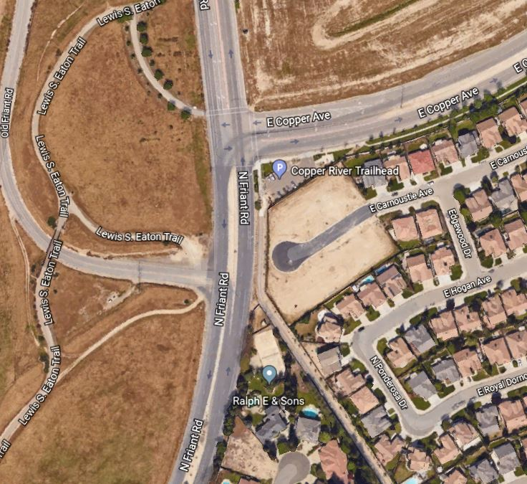

Valley Arboretum:
The Valley Arboretum, a system of greenways, is becoming a signature amenity for the Fresno region. Adopted by reference in the 2014 General Plan, the San Joaquin River Parkway, Sugar Pine Trail, Old Town Clovis Trail, and the new Mid-Town Trail are notable components. Please join us in supporting a Special District to fund the care and development of greenways in our region.

Like Tree Fresno on Facebook for Volunteer Opportunities and Updates

